Name:  Teacher: | ____________________________________  ________________ |  | Date:_________
 | Year 9 Mathematics  SCORE:  / 35  Mini test 6  Topic – Linear Equations  Full working out MUST be shown to get full marks for each question.
Total Time: | 38 minutes
Weighting: | 5 %
Equipment: | To be provided by the student: Pens and Pencils, scientific calculator, A4 page of notes.

Part A – Multiple-choice questions (5 marks)

1. What does ‘c’ represent in y = mx + c ?

A y - intercept B gradient C axis
D x - intercept E coordinate

2. Write the equation of a line where the gradient is 1 and the y – intercept is 8.

A y = 8x B x = 8 C y = 8
D y = 8x + 1 E y = x + 8

3. The gradient of the following line is:

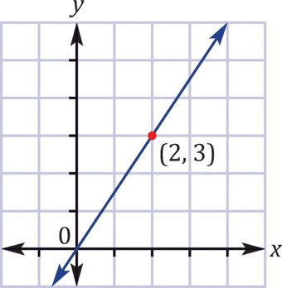
A B C
D E 23

4. The midpoint of the line segment joining the points (4, –3) and (8, 5) is:

A (1, 6) B (6, –1) C (–6, 1)

D (6, 1) E (–1, 6)

5. The length of the line segment joining the points (1, –3) and (–2, 1) is:

A 5 B 7 C 6

D E

Part B – Short Answer (30 marks)

6. For each graph state whether the gradient is positive, negative, zero or undefined, and then find the gradient where possible. (1,1,2,2 – 6 marks)

a 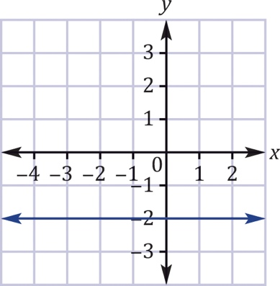 b 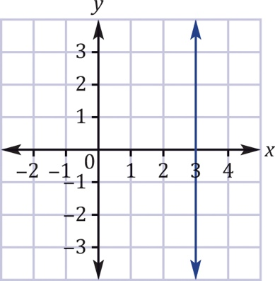

c 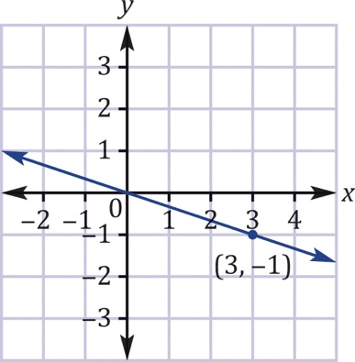 d 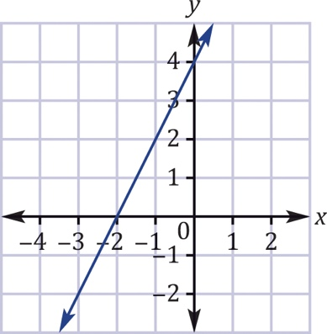

7. Sketch the graphs of the following linear relationships (each small square = 1 unit).
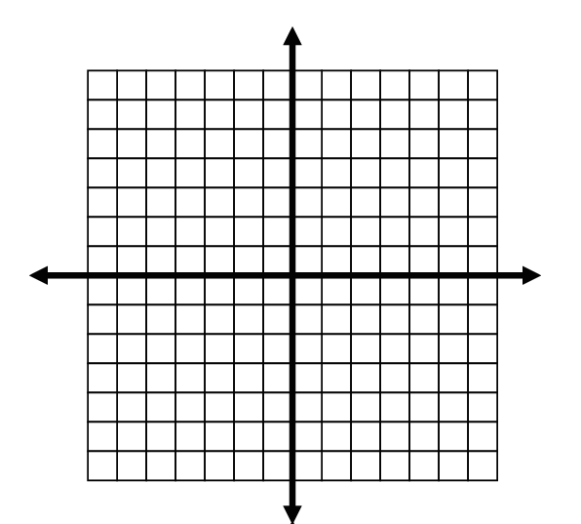
(2, 2= 4 marks)
  - $y=2x- 2$


b.$y=-x- 3$

8. Consider the following rules: (4, 2, 4 = 10 marks)

- $y=2x-4$
- $y=-3x+2$
(i) Construct separate tables of values for the two rules

(ii) Plot the coordinates from your two table of values in (i) on the graph below and draw a straight line connecting the coordinates.

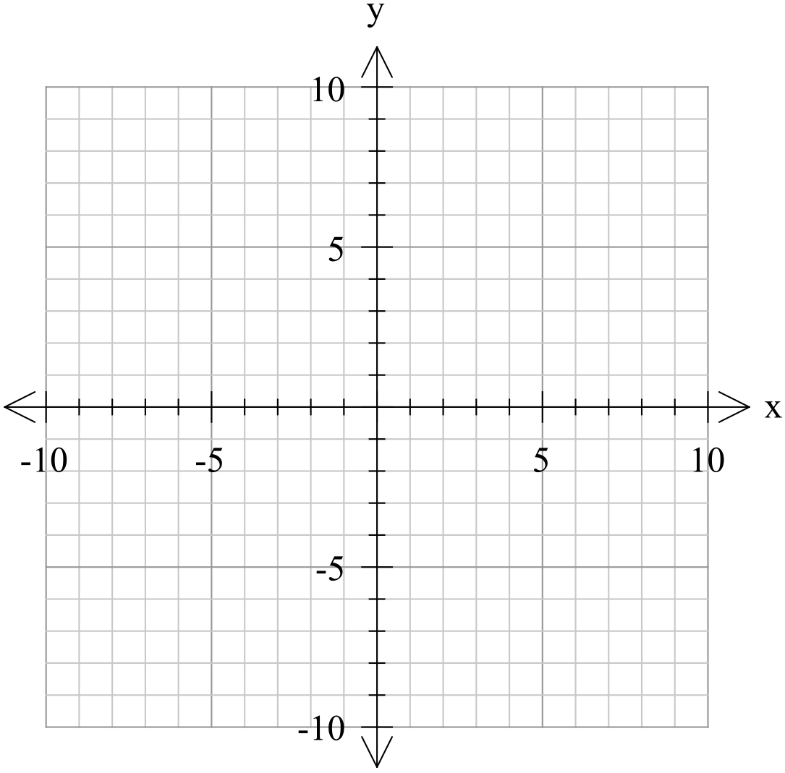

(iii) From the graph, write the co-ordinates of the following:
x-intercept: y-intercept:

9. Using the following co-ordinates (2,7) and (-3, 5): (2, 2, 2 – 6 marks)

i) Plot them on the graph below



ii) Find the co-ordinates of the midpoint of the two points algebraically.

iii) Find the length of the line segment joining these two points algebraically.

10. A triangle is formed using the points (-1, 3), (4, 8) and (3,-2) what is the perimeter of the triangle? (4 marks)

